I am a total “noob” at coding, so this is my first shot at any kind of templating.

My design is geared towards simplicity… it had to be, because I really didn’t know what I was doing. ;-)

This design has been testing in the “big three” browsers (IE6, IE7, and Firefox). While there are subtle differences in each browser, it is the inherent characteristics of the browser(s) and not due to the template layout.

I have made my graphics (logo, content, menu buttons, backgrounds and shadowing, etc.) with Adobe Photoshop and saved them as .PSD. The layers are intact, so they’d be easy to make whatever graphics and/or color changes you want. I have also saved them as .PNG for anyone who wants to keep the graphics as they are in high-quality mode (larger file), and as .GIF for smaller size files. In addition to the .GIF images I use for the template, I’ve also put copies and the original .PSD and .PNG files in a separate folder called “psd_png_images” in the template folder.

This is done with a default template from 2.4.1 – no addons or code tweaks with this single exception: in “include/images.inc.php” I changed line #745 from this “<a href="javascript:;" onclick="SLIDES.play()">Play</a>” to this: “<a href="javascript:;" onclick="SLIDES.play()">Play</a>&nbsp;&nbsp;&nbsp; ”. What this did was add 3 spaces between the “play” slideshow link and the “pause” slideshow link. This is not necessary for you to change, only something I wanted to do purely for aesthetic reasons. The original file is in the “orig_files” folder in the “include” folder – change it or not as you wish.

The page setup/layout is such that there are custom listing views so they would fit the page. There were nine template files I changed: view_users_default.html, view_user_default.html, style.css, search_result_default.html, search_page_default.html, search_class_default.html, main.html, listing_detail_slideshow.html, and featured_listing_horizontal.html. I have saved a copy of the original files and placed them in a separate folder called “orig_files”, and put backup copies of the files I changed into a folder called “changed_files”; both are in the template folder.

I have the Featured Listings in with the Welcome Page instead of the main.html page – I did this because I personally don’t like the Featured Listings to be on each page you visit. With it on the welcome page, they only show up on the home page and none of the other pages (except the “Quick Search” page {search_page_default.html}).

The changed that were made to “Site Config” are as follows (otherwise it’s a basic default setup - with your own personal configuration of course):

Template Tab
Site Template: autumn_candy
Listing Template: Slideshow

Editor/HTML Tab
WYSIWYG Editor: FckEditor

Uploads Tab
Upload Limits
Max Image Width: 350
Max Image Height: 700

☺

Main Page screenshot:
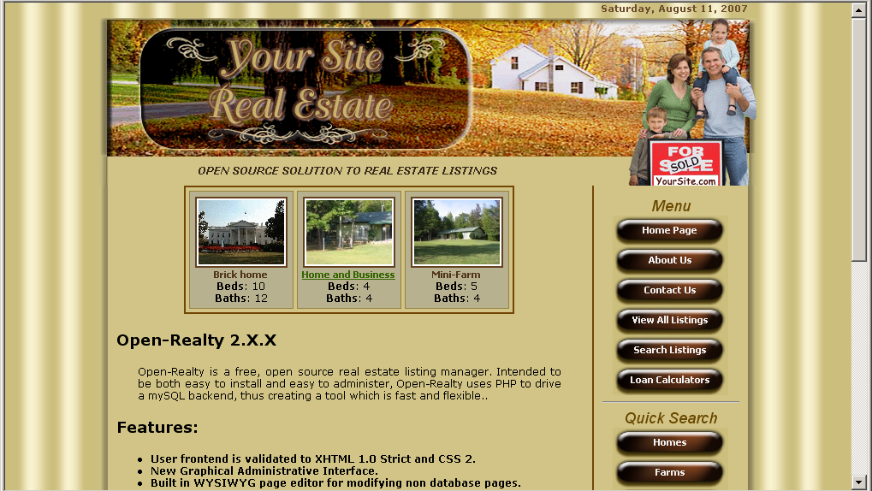

View All Listings screenshot:
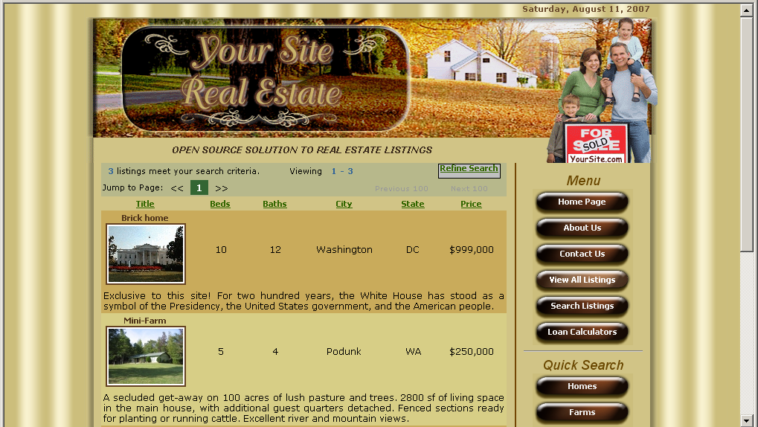

Quick Search screenshot:
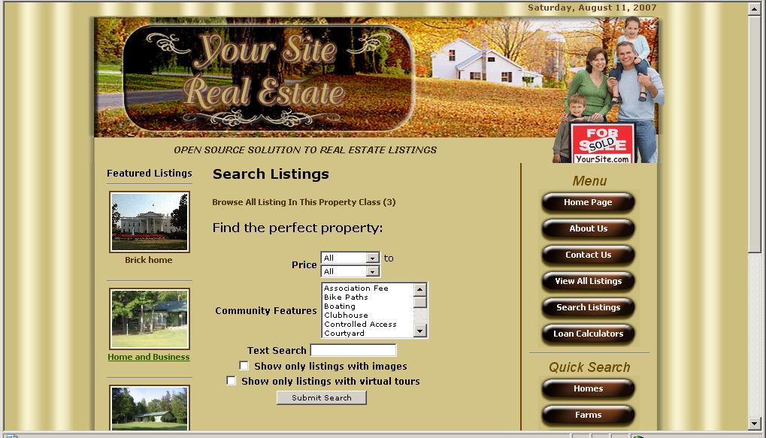

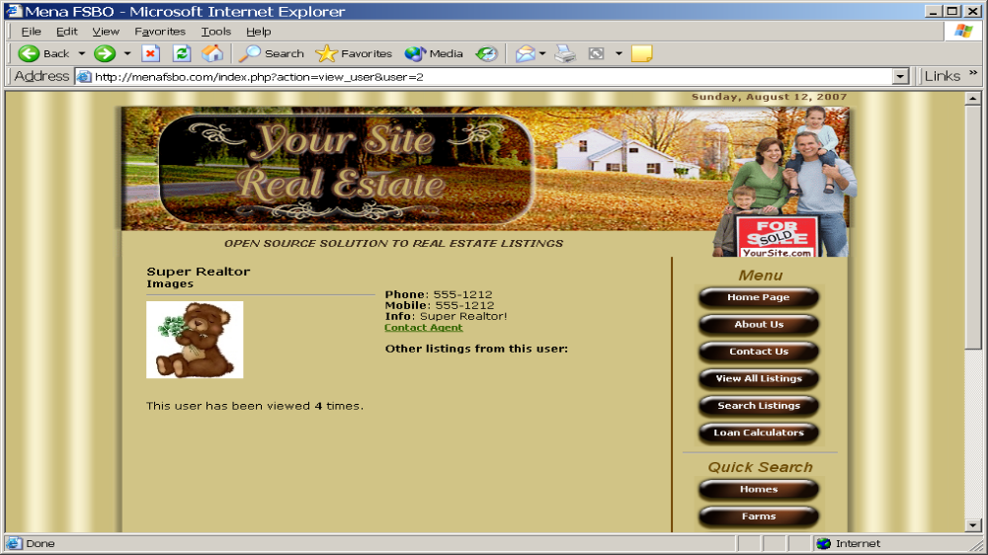
View Agents screenshot:

